Desktop Keyboard
Feel-good typing that's built to go the distance

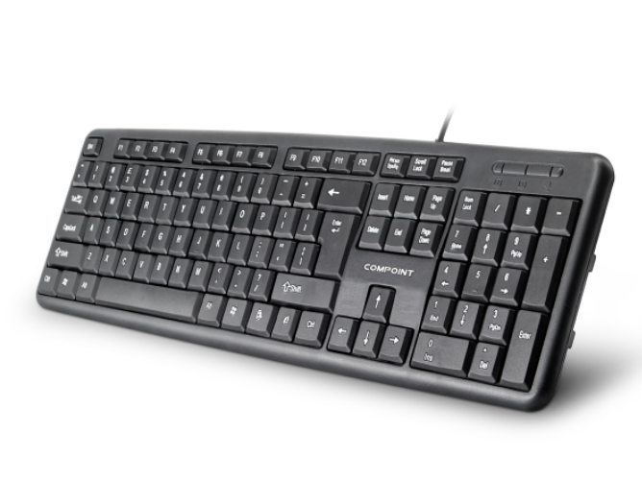

Descrption:

More than just good looks..
We've designed the new K9014 keyboard not just to look good on your desk but also promote a more natural and restful typing action, reducing common problems associated with poorly designed keyboards. Take for example our low-profile keys, a tilted keyboard-body to further reduce wrist strains after extended usage. Whisper-quiet operation is assured on the full-size keyboard with separate numeric pad, cursor control and of course multimedia keys.

Ideal for tablet and mobile computing devices..

Being totally Plug n' Play, the K9014 keyboard is also compatible with AndroidTM tablet devices which have a USB port available (or via a on-the-go adapter), which makes typing faster and or course more accurate than touching a screen. Its also ideal for the RaspberryTM PI computer, whereby a low-cost but multifunction keyboard is required.

Features:

Comfortable typing with tactile feedback

Full control of your multimedia experience

USB Plug n' Play - for Windows, Mac, Linux, Android Tablets etc

System Requirements: Windows 2000, XP, WindowsTM Vista, WindowsTM 7 or WindowsTM 10 MacTM OS X (10.4 or higher) LinuxTM kernel 2.6+ AndroidTM version 4.1 or higher RaspberryTM PI USB port

Specifications
- material :ABS material
- Port：USB
- Cable: 1.5M lenght
- Low-profile, quiet keys
- Full-size keyboard
- Thin-profile keyboard
- Spill-resistant design
- Durable keys that can last
- up to 10 million keystrokes
- Strong, adjustable tilt legs
- Plug-and-play USB connection
- Bold, bright characters
- No software installation
- Certificate: CE FCC ROHS
- Operating Temperature:0℃ to +45℃
- Operating Humidity:10%0 to 85 % RH
- Storage Temperature : -10℃ to +55℃
- Storage Humidity: 5% to 90 % RH

Product Code:
Part number: K8014
Barcode: 8400800032997
Size: 44X14X2.5 cm
Weight: 0.360 kg

